EXPERIMENT 10
BI Deployment, Monitoring and Backup & Restore using Microsoft Power BI
Aim
To design and develop Power BI report pages for BI deployment planning, monitoring activities, backup scheduling and disaster recovery management.
1. BI Deployment Overview
The first page, BI Deployment Overview, presents the main Business Intelligence assets planned for organizational deployment.
The page contains:
- KPI Cards: Total Reports, Total Dashboards, Total Datasets and Total Workspaces.
- Clustered Column Chart: BI Assets by Category.
- Text Box: Deployment Objectives.
This page helps identify BI resources and understand the deployment requirements of different organizational departments.
Figure 1: BI Deployment Overview
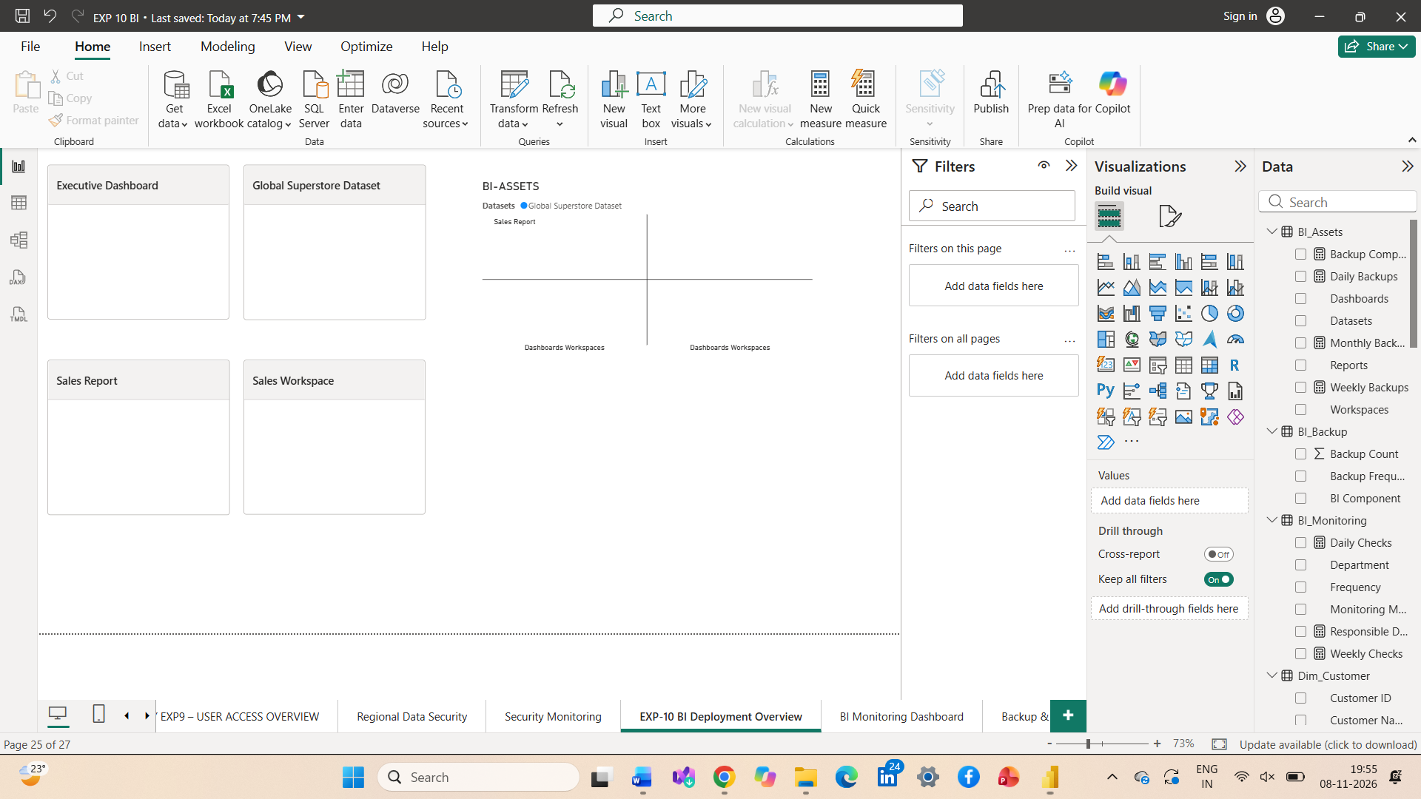
2. BI Monitoring Dashboard
The second page, BI Monitoring Dashboard, presents the monitoring activities required to maintain the reliability and performance of the BI system.
The page contains:
- KPI Cards: Monitoring Activities, Daily Checks, Weekly Checks and Responsible Departments.
- Clustered Column Chart: Monitoring Activities by Metric.
- Clustered Bar Chart: Monitoring Activities by Department.
This page helps identify important monitoring activities, their frequency and the departments responsible for performing them.
Figure 2: BI Monitoring Dashboard
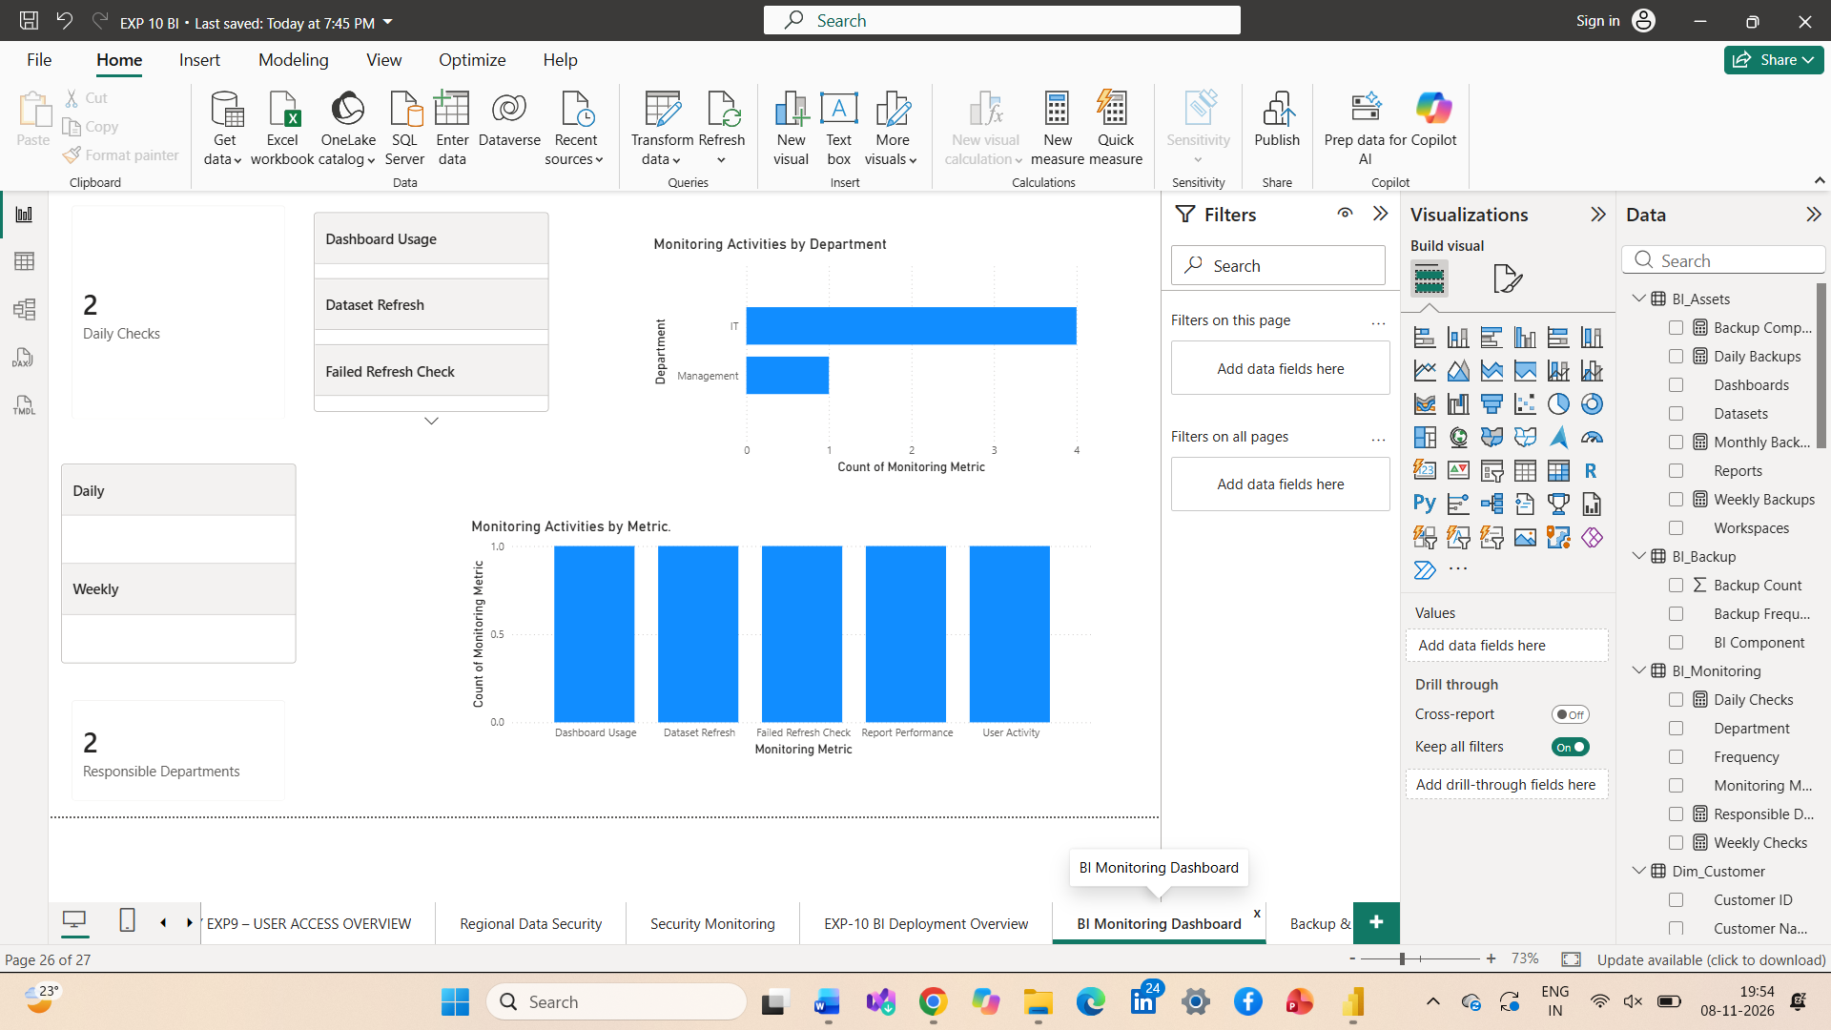
3. Backup & Recovery Management
The third page, Backup & Recovery Management, presents the backup schedule and disaster recovery procedure for protecting BI assets.
The page contains:
- KPI Cards: Backup Components, Daily Backups, Weekly Backups and Monthly Backups.
- Clustered Column Chart: BI Backup Schedule.
- Text Box: Disaster Recovery Procedure.
This page helps understand backup frequency and the steps required to restore BI reports in case of accidental deletion or system failure.
Figure 3: Backup & Recovery Management
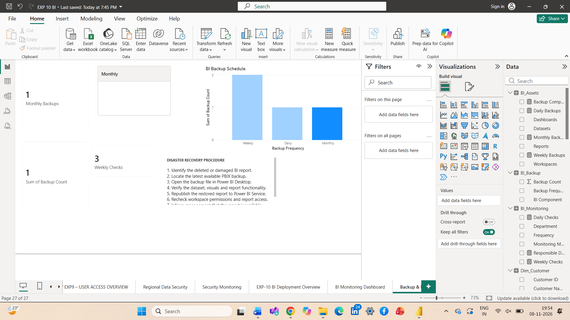
Result
Successfully designed three Power BI report pages covering BI deployment planning, monitoring activities, backup scheduling and disaster recovery management for the Global Superstore organization.
Learning Outcomes
- Understood BI deployment planning and asset management.
- Learned how to design monitoring dashboards and identify monitoring responsibilities.
- Understood backup scheduling and disaster recovery procedures.

